Отчет 111_4

1. Параметры здания

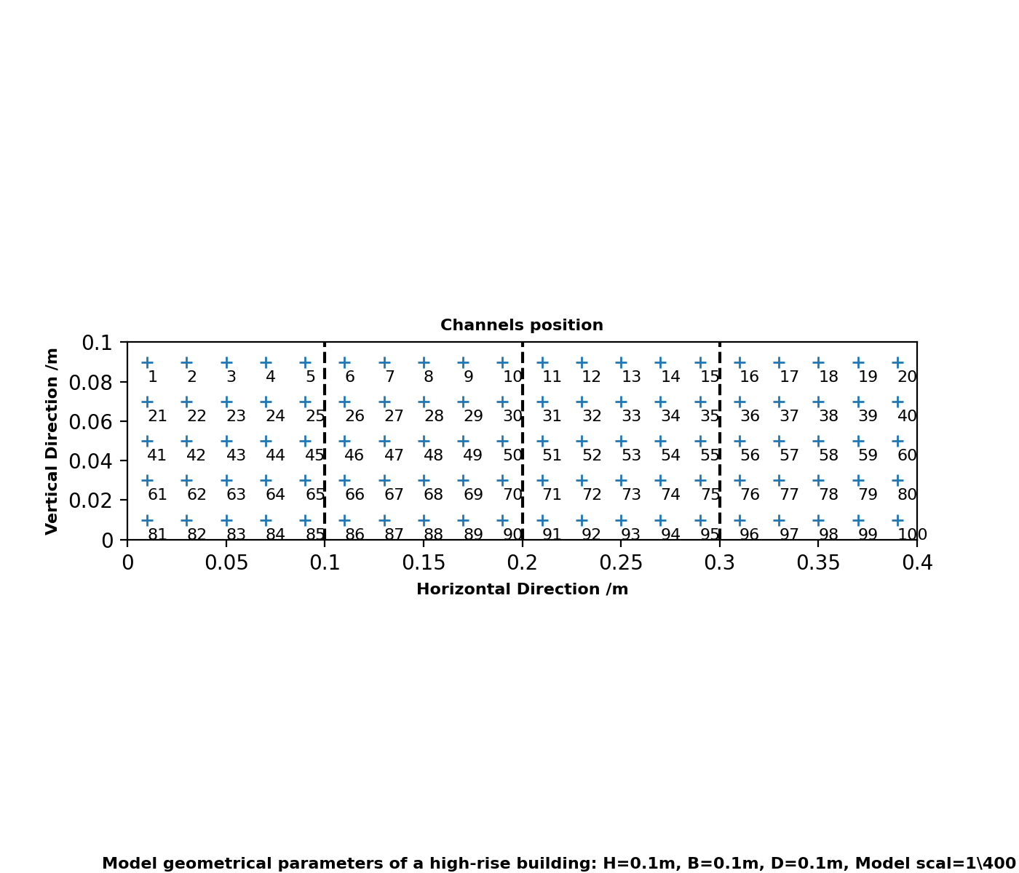

2. Статистика по датчиках. Максимумы и огибающие

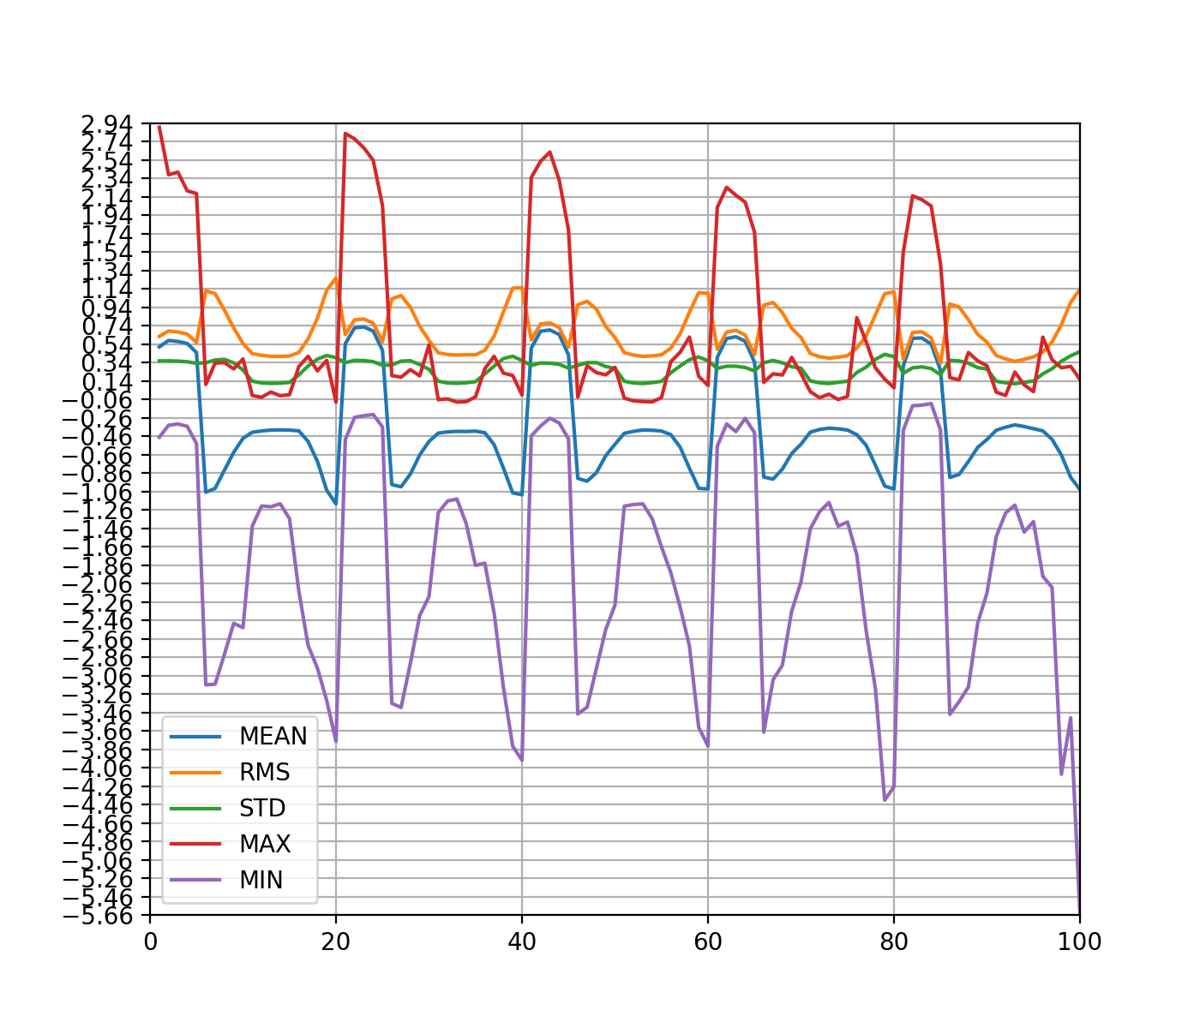  
Огибающие 111_4 угол 00

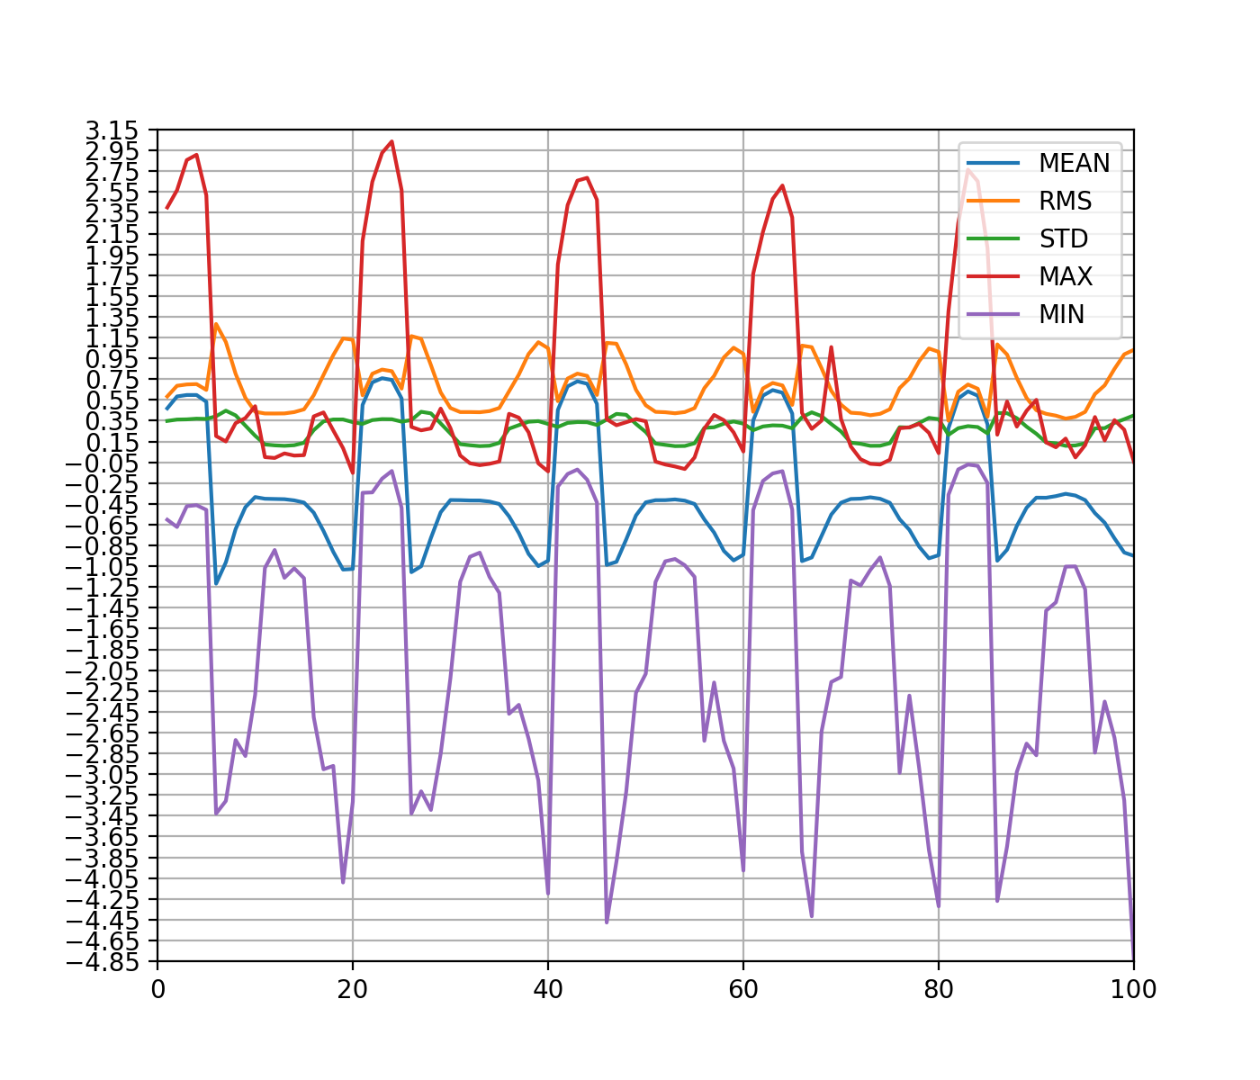  
Огибающие 111_4 угол 05

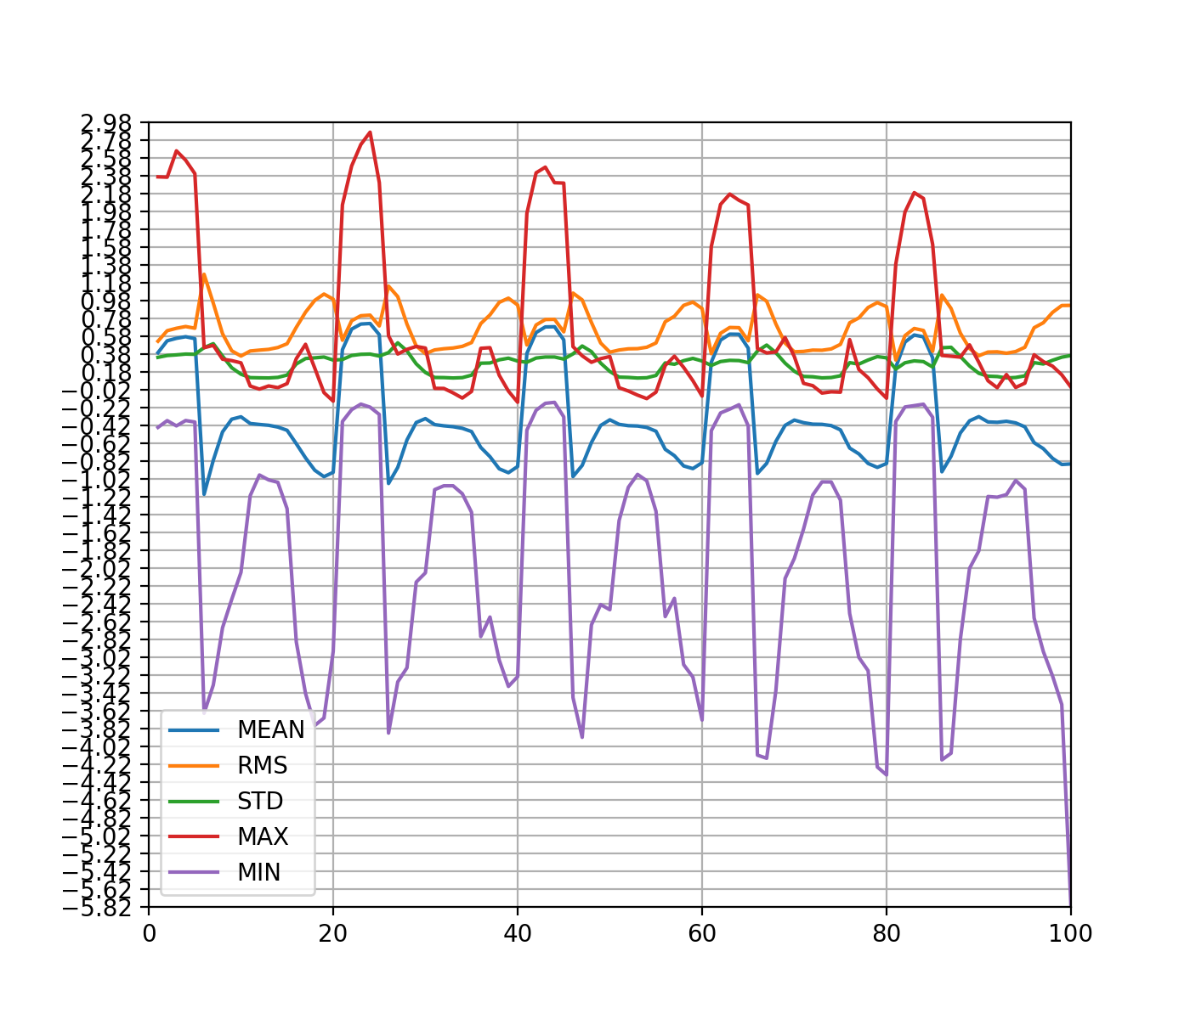  
Огибающие 111_4 угол 10

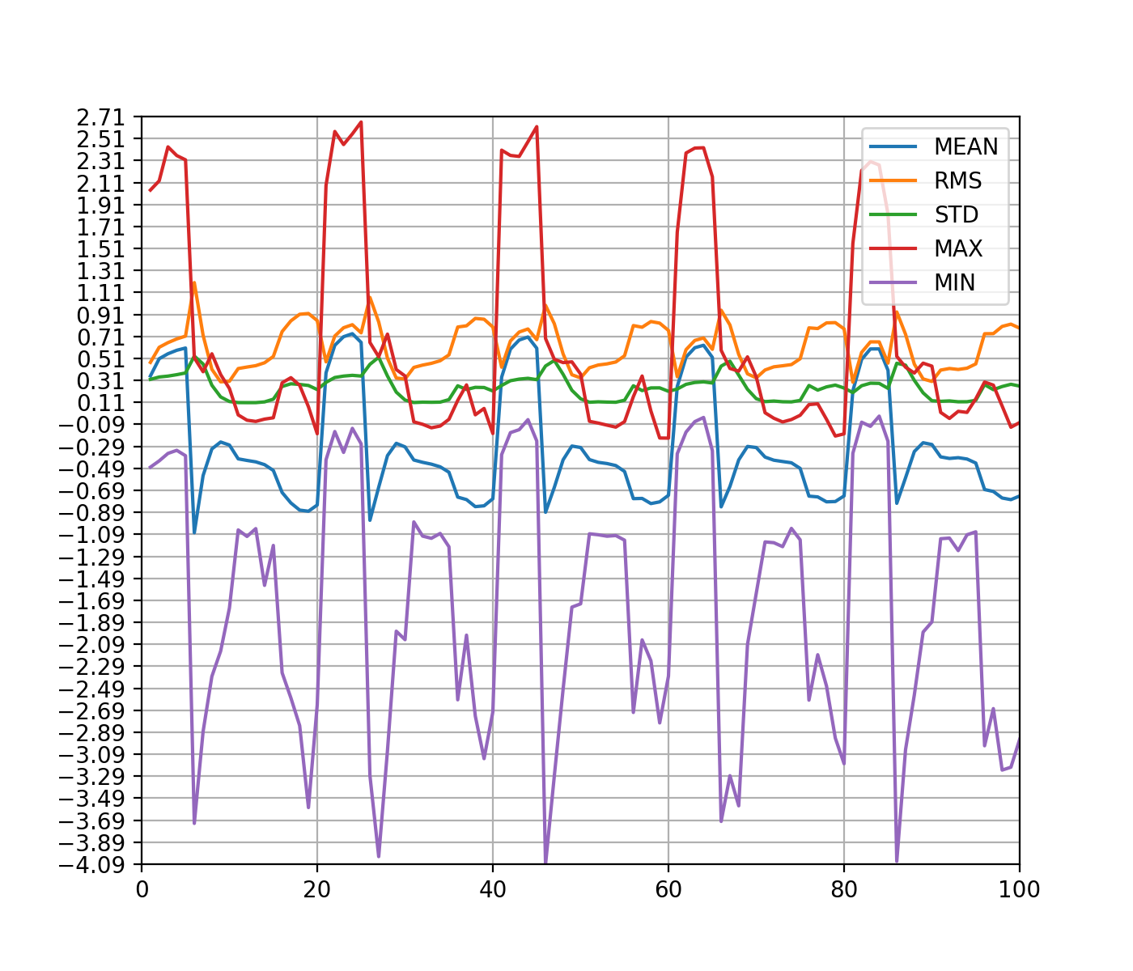  
Огибающие 111_4 угол 15

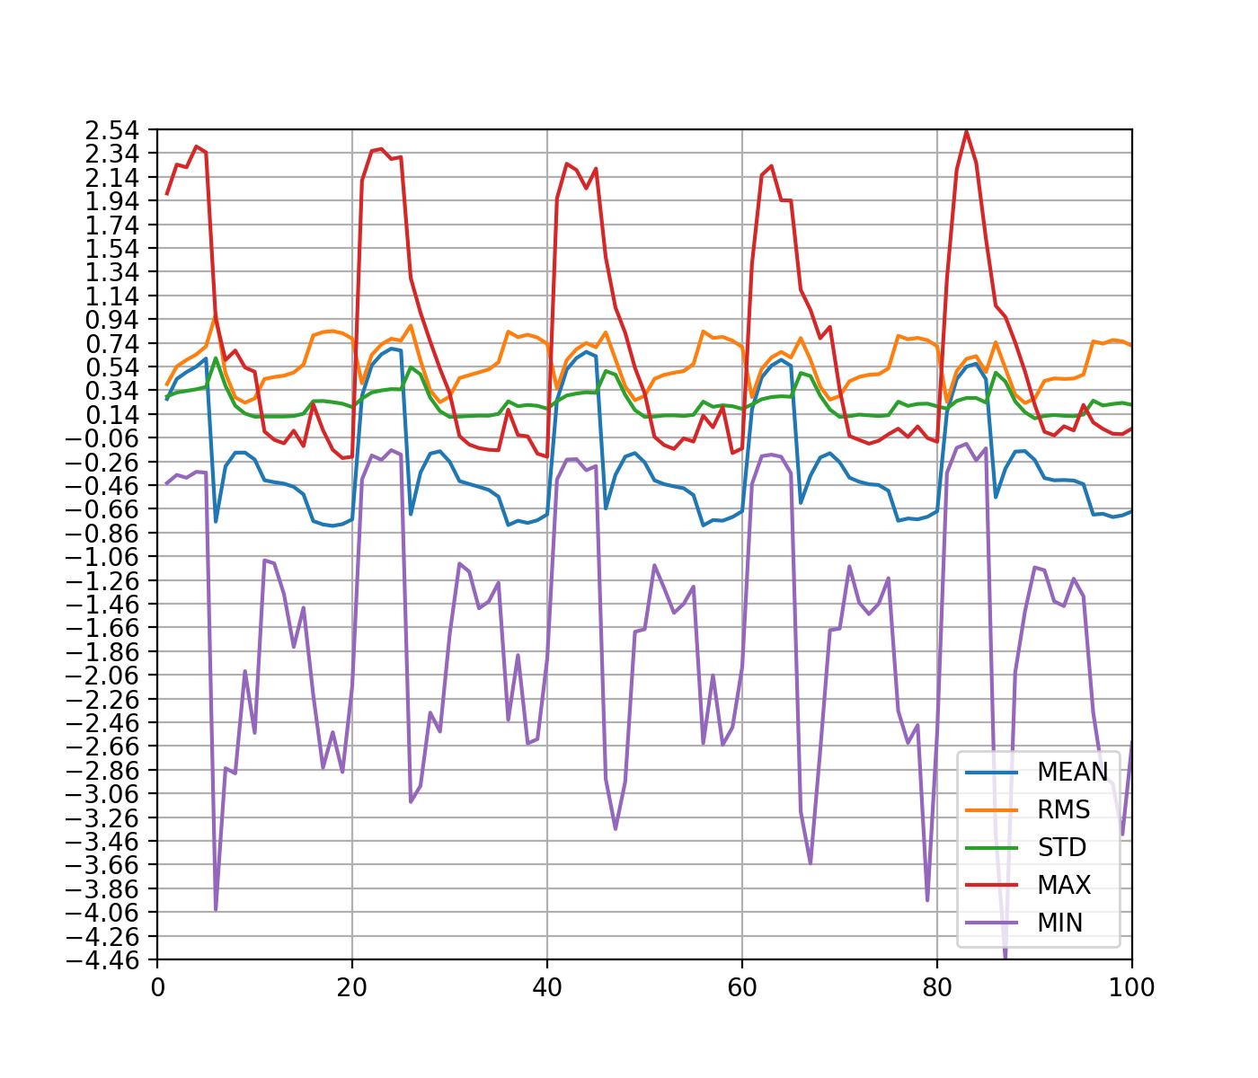  
Огибающие 111_4 угол 20

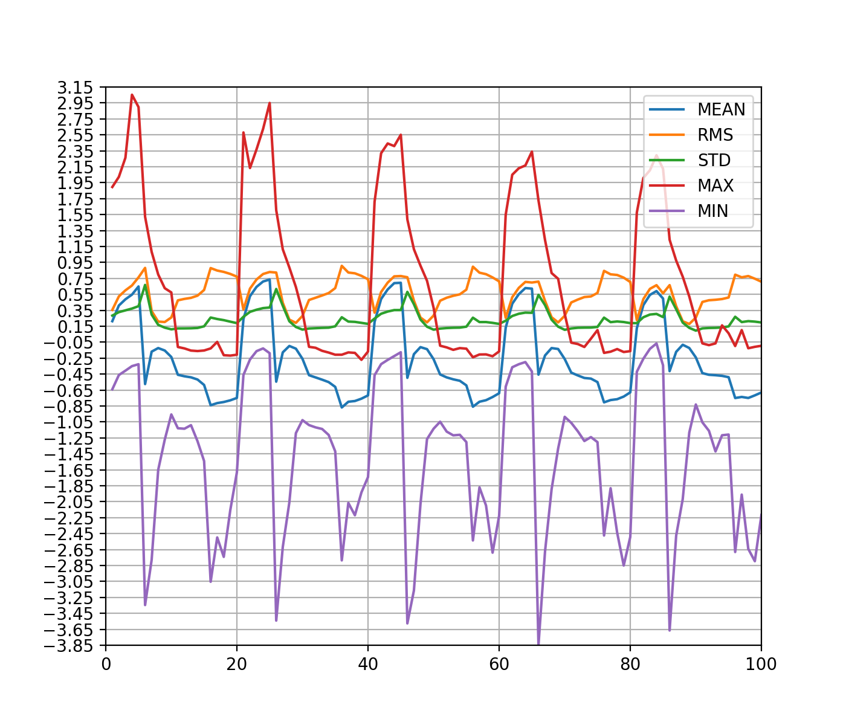  
Огибающие 111_4 угол 25

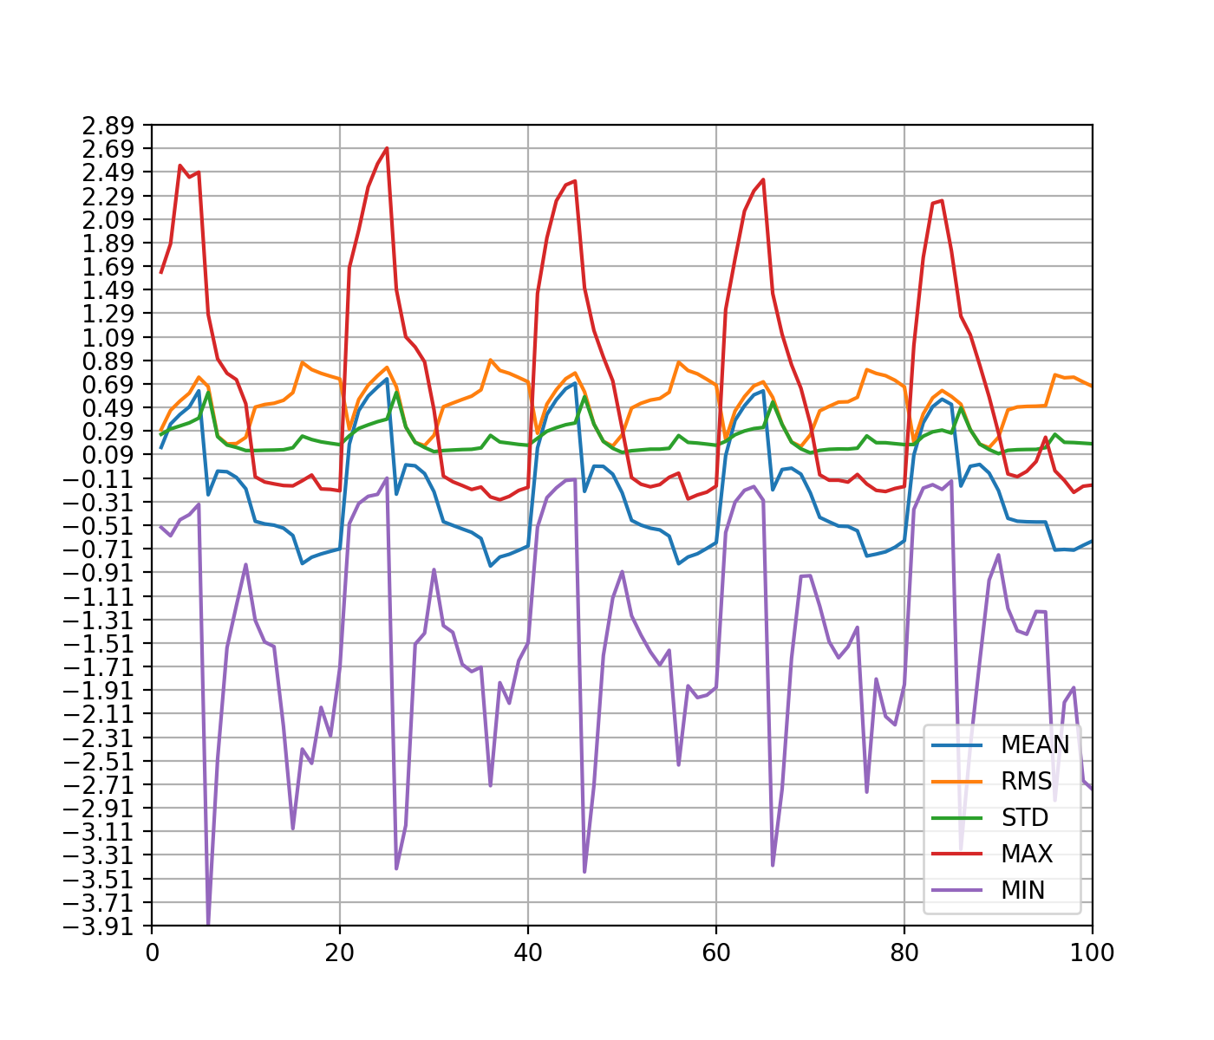  
Огибающие 111_4 угол 30

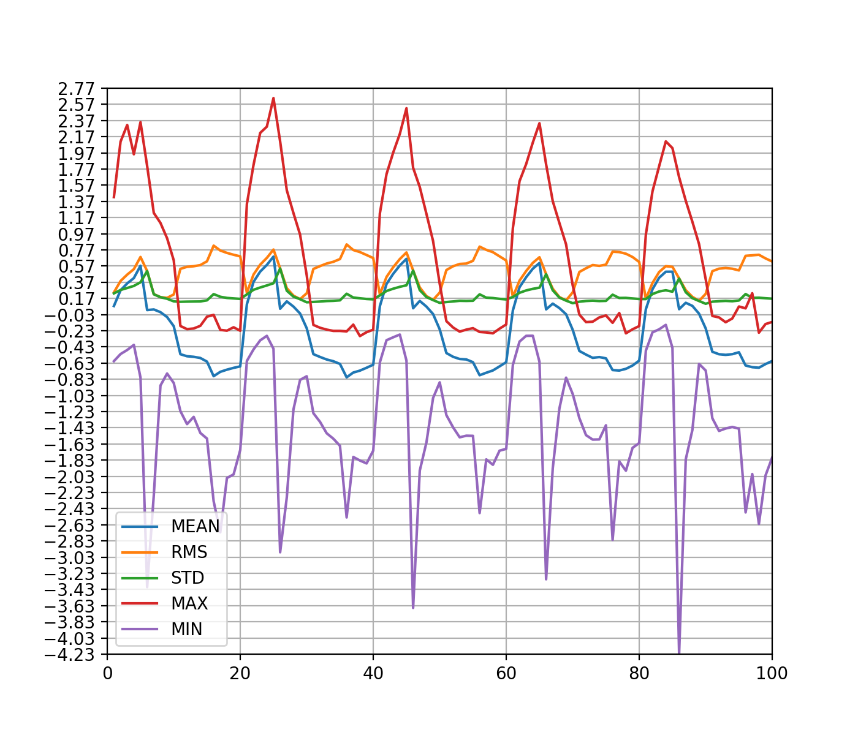  
Огибающие 111_4 угол 35

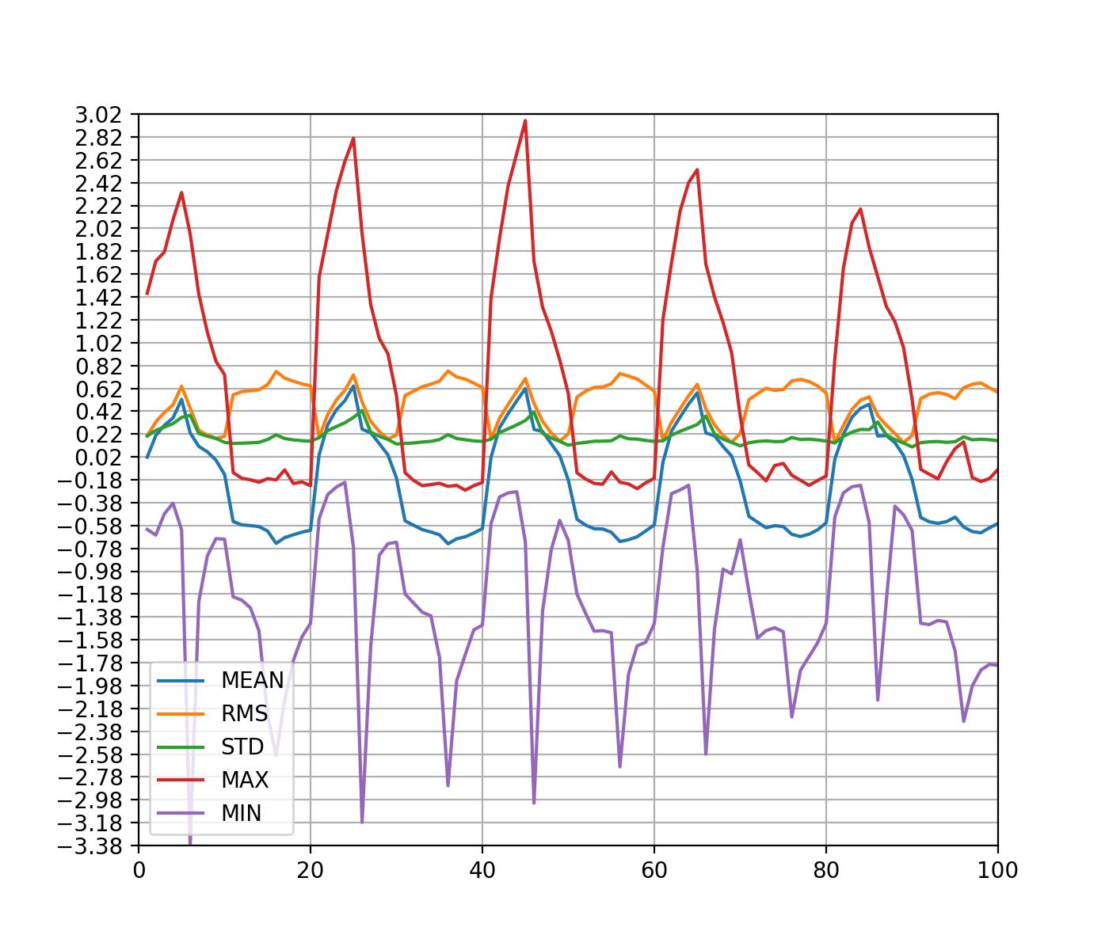  
Огибающие 111_4 угол 40

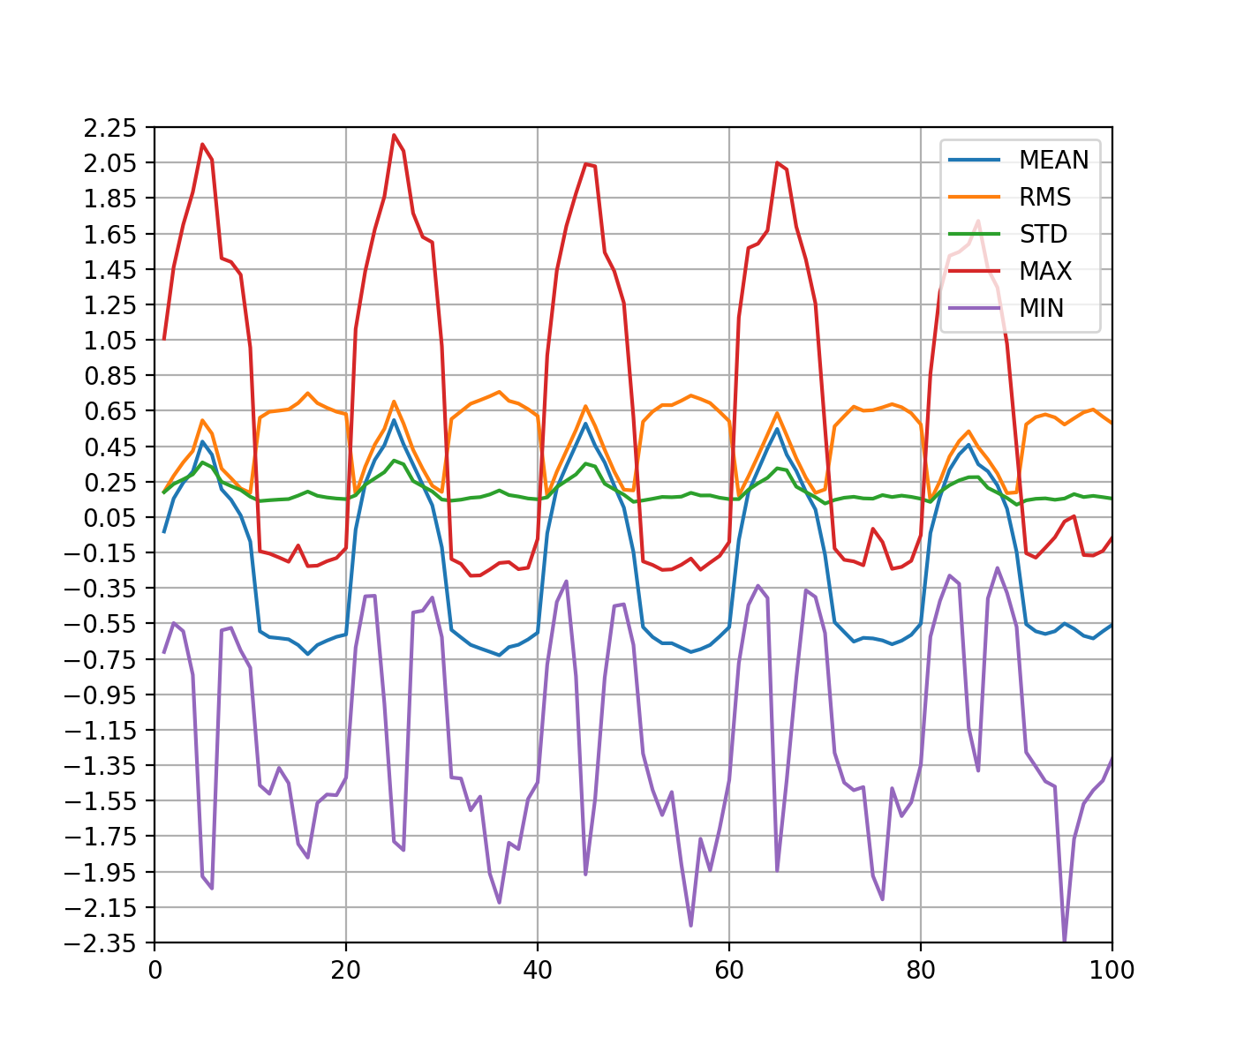  
Огибающие 111_4 угол 45

3. Статистика по датчикам в табличном виде   
Таблица 1. ТПУ 111_4, RUMB=0 Аэродинамический коэффициент в датчиках

|  |  |  |  |  |  |  |  |  |  |  |  |
| --- | --- | --- | --- | --- | --- | --- | --- | --- | --- | --- | --- |
| ДАТЧИК | X(мм) | Y(мм) | Z(мм) | СРЕДНЕЕ | RMS | СТАНДАРТНОЕ ОТКЛОНЕНИЕ | МАКСИМУМ | МИНИМУМ | РАСЧЕТНОЕ | ОБЕСП+ | ОБЕСП- |
| 1 | -0.05 | 0.04 | 0.09 | 0.5117 | 0.6251 | 0.359 | 2.897 | -0.47 | None | None | None |
| 2 | -0.05 | 0.02 | 0.09 | 0.5817 | 0.6843 | 0.3604 | 2.382 | -0.34 | None | None | None |
| 3 | -0.05 | 0.0 | 0.09 | 0.5702 | 0.6726 | 0.3569 | 2.41 | -0.326 | None | None | None |
| 4 | -0.05 | -0.02 | 0.09 | 0.5487 | 0.6507 | 0.3498 | 2.207 | -0.351 | None | None | None |
| 5 | -0.05 | -0.04 | 0.09 | 0.4498 | 0.5596 | 0.333 | 2.178 | -0.539 | None | None | None |
| 6 | -0.04 | -0.05 | 0.09 | -1.0675 | 1.1201 | 0.3392 | 0.103 | -3.16 | None | None | None |
| 7 | -0.02 | -0.05 | 0.09 | -1.0261 | 1.0903 | 0.3688 | 0.336 | -3.153 | None | None | None |
| 8 | -0.0 | -0.05 | 0.09 | -0.829 | 0.9104 | 0.3763 | 0.341 | -2.83 | None | None | None |
| 9 | 0.02 | -0.05 | 0.09 | -0.6341 | 0.7186 | 0.338 | 0.272 | -2.492 | None | None | None |
| 10 | 0.04 | -0.05 | 0.09 | -0.4822 | 0.5474 | 0.2591 | 0.38 | -2.539 | None | None | None |
| 11 | 0.05 | -0.04 | 0.09 | -0.4157 | 0.4382 | 0.1387 | -0.017 | -1.435 | None | None | None |
| 12 | 0.05 | -0.02 | 0.09 | -0.4021 | 0.4196 | 0.1199 | -0.036 | -1.217 | None | None | None |
| 13 | 0.05 | -0.0 | 0.09 | -0.3926 | 0.409 | 0.1147 | 0.021 | -1.225 | None | None | None |
| 14 | 0.05 | 0.02 | 0.09 | -0.3909 | 0.4081 | 0.1173 | -0.019 | -1.193 | None | None | None |
| 15 | 0.05 | 0.04 | 0.09 | -0.3925 | 0.412 | 0.1254 | -0.008 | -1.354 | None | None | None |
| 16 | 0.04 | 0.05 | 0.09 | -0.4009 | 0.4511 | 0.2068 | 0.297 | -2.138 | None | None | None |
| 17 | 0.02 | 0.05 | 0.09 | -0.5153 | 0.5979 | 0.3032 | 0.41 | -2.732 | None | None | None |
| 18 | 0.0 | 0.05 | 0.09 | -0.7316 | 0.8236 | 0.3783 | 0.251 | -2.978 | None | None | None |
| 19 | -0.02 | 0.05 | 0.09 | -1.0459 | 1.1262 | 0.4175 | 0.365 | -3.33 | None | None | None |
| 20 | -0.04 | 0.05 | 0.09 | -1.1943 | 1.2579 | 0.3949 | -0.089 | -3.775 | None | None | None |
| 21 | -0.05 | 0.04 | 0.07 | 0.5467 | 0.6438 | 0.34 | 2.831 | -0.496 | None | None | None |
| 22 | -0.05 | 0.02 | 0.07 | 0.7189 | 0.8063 | 0.3652 | 2.771 | -0.254 | None | None | None |
| 23 | -0.05 | 0.0 | 0.07 | 0.7286 | 0.814 | 0.3629 | 2.673 | -0.236 | None | None | None |
| 24 | -0.05 | -0.02 | 0.07 | 0.6834 | 0.7683 | 0.351 | 2.539 | -0.223 | None | None | None |
| 25 | -0.05 | -0.04 | 0.07 | 0.4737 | 0.5667 | 0.3112 | 2.047 | -0.358 | None | None | None |
| 26 | -0.04 | -0.05 | 0.07 | -0.9844 | 1.0332 | 0.3139 | 0.199 | -3.361 | None | None | None |
| 27 | -0.02 | -0.05 | 0.07 | -1.0082 | 1.0695 | 0.3571 | 0.182 | -3.406 | None | None | None |
| 28 | -0.0 | -0.05 | 0.07 | -0.87 | 0.9419 | 0.361 | 0.264 | -2.926 | None | None | None |
| 29 | 0.02 | -0.05 | 0.07 | -0.6629 | 0.7354 | 0.3185 | 0.197 | -2.408 | None | None | None |
| 30 | 0.04 | -0.05 | 0.07 | -0.516 | 0.5814 | 0.268 | 0.532 | -2.2 | None | None | None |
| 31 | 0.05 | -0.04 | 0.07 | -0.4252 | 0.4473 | 0.1387 | -0.062 | -1.29 | None | None | None |
| 32 | 0.05 | -0.02 | 0.07 | -0.4122 | 0.4291 | 0.1194 | -0.054 | -1.163 | None | None | None |
| 33 | 0.05 | -0.0 | 0.07 | -0.4065 | 0.4227 | 0.1157 | -0.088 | -1.142 | None | None | None |
| 34 | 0.05 | 0.02 | 0.07 | -0.4081 | 0.4259 | 0.1218 | -0.084 | -1.408 | None | None | None |
| 35 | 0.05 | 0.04 | 0.07 | -0.4037 | 0.4252 | 0.1335 | -0.032 | -1.863 | None | None | None |
| 36 | 0.04 | 0.05 | 0.07 | -0.4211 | 0.4738 | 0.217 | 0.275 | -1.838 | None | None | None |
| 37 | 0.02 | 0.05 | 0.07 | -0.5499 | 0.6274 | 0.302 | 0.409 | -2.379 | None | None | None |
| 38 | 0.0 | 0.05 | 0.07 | -0.8045 | 0.8918 | 0.3848 | 0.227 | -3.187 | None | None | None |
| 39 | -0.02 | 0.05 | 0.07 | -1.0741 | 1.1498 | 0.4102 | 0.201 | -3.826 | None | None | None |
| 40 | -0.04 | 0.05 | 0.07 | -1.0951 | 1.1534 | 0.3623 | -0.012 | -3.98 | None | None | None |
| 41 | -0.05 | 0.04 | 0.05 | 0.4986 | 0.5872 | 0.3101 | 2.353 | -0.456 | None | None | None |
| 42 | -0.05 | 0.02 | 0.05 | 0.6817 | 0.7603 | 0.3367 | 2.528 | -0.348 | None | None | None |
| 43 | -0.05 | 0.0 | 0.05 | 0.6953 | 0.7714 | 0.3341 | 2.628 | -0.264 | None | None | None |
| 44 | -0.05 | -0.02 | 0.05 | 0.646 | 0.7218 | 0.3219 | 2.325 | -0.315 | None | None | None |
| 45 | -0.05 | -0.04 | 0.05 | 0.4242 | 0.5087 | 0.2808 | 1.782 | -0.488 | None | None | None |
| 46 | -0.04 | -0.05 | 0.05 | -0.9172 | 0.9681 | 0.3098 | -0.035 | -3.477 | None | None | None |
| 47 | -0.02 | -0.05 | 0.05 | -0.9477 | 1.0071 | 0.3407 | 0.307 | -3.403 | None | None | None |
| 48 | -0.0 | -0.05 | 0.05 | -0.856 | 0.9212 | 0.3405 | 0.232 | -2.981 | None | None | None |
| 49 | 0.02 | -0.05 | 0.05 | -0.6718 | 0.735 | 0.2982 | 0.208 | -2.561 | None | None | None |
| 50 | 0.04 | -0.05 | 0.05 | -0.5463 | 0.6129 | 0.2779 | 0.289 | -2.293 | None | None | None |
| 51 | 0.05 | -0.04 | 0.05 | -0.4271 | 0.4488 | 0.138 | -0.046 | -1.219 | None | None | None |
| 52 | 0.05 | -0.02 | 0.05 | -0.4056 | 0.4226 | 0.1187 | -0.074 | -1.201 | None | None | None |
| 53 | 0.05 | -0.0 | 0.05 | -0.3918 | 0.408 | 0.1138 | -0.083 | -1.194 | None | None | None |
| 54 | 0.05 | 0.02 | 0.05 | -0.3943 | 0.4131 | 0.1232 | -0.086 | -1.355 | None | None | None |
| 55 | 0.05 | 0.04 | 0.05 | -0.4032 | 0.4258 | 0.137 | -0.04 | -1.662 | None | None | None |
| 56 | 0.04 | 0.05 | 0.05 | -0.4417 | 0.4981 | 0.2302 | 0.35 | -1.941 | None | None | None |
| 57 | 0.02 | 0.05 | 0.05 | -0.5765 | 0.6514 | 0.3032 | 0.453 | -2.315 | None | None | None |
| 58 | 0.0 | 0.05 | 0.05 | -0.8054 | 0.8876 | 0.3729 | 0.618 | -2.735 | None | None | None |
| 59 | -0.02 | 0.05 | 0.05 | -1.0251 | 1.1011 | 0.4018 | 0.191 | -3.621 | None | None | None |
| 60 | -0.04 | 0.05 | 0.05 | -1.0322 | 1.0934 | 0.3605 | 0.093 | -3.825 | None | None | None |
| 61 | -0.05 | 0.04 | 0.03 | 0.3986 | 0.4857 | 0.2774 | 2.027 | -0.567 | None | None | None |
| 62 | -0.05 | 0.02 | 0.03 | 0.6022 | 0.6734 | 0.3014 | 2.245 | -0.326 | None | None | None |
| 63 | -0.05 | 0.0 | 0.03 | 0.6217 | 0.6908 | 0.3012 | 2.159 | -0.409 | None | None | None |
| 64 | -0.05 | -0.02 | 0.03 | 0.5718 | 0.6401 | 0.2875 | 2.084 | -0.266 | None | None | None |
| 65 | -0.05 | -0.04 | 0.03 | 0.3462 | 0.4276 | 0.2509 | 1.758 | -0.42 | None | None | None |
| 66 | -0.04 | -0.05 | 0.03 | -0.9033 | 0.9648 | 0.339 | 0.126 | -3.674 | None | None | None |
| 67 | -0.02 | -0.05 | 0.03 | -0.9248 | 0.994 | 0.3642 | 0.219 | -3.105 | None | None | None |
| 68 | -0.0 | -0.05 | 0.03 | -0.8158 | 0.8833 | 0.3385 | 0.206 | -2.946 | None | None | None |
| 69 | 0.02 | -0.05 | 0.03 | -0.6472 | 0.7116 | 0.2959 | 0.397 | -2.359 | None | None | None |
| 70 | 0.04 | -0.05 | 0.03 | -0.5457 | 0.6135 | 0.2803 | 0.221 | -2.042 | None | None | None |
| 71 | 0.05 | -0.04 | 0.03 | -0.4154 | 0.439 | 0.1421 | 0.025 | -1.465 | None | None | None |
| 72 | 0.05 | -0.02 | 0.03 | -0.3858 | 0.4044 | 0.1212 | -0.041 | -1.279 | None | None | None |
| 73 | 0.05 | -0.0 | 0.03 | -0.3719 | 0.3888 | 0.1136 | -0.002 | -1.179 | None | None | None |
| 74 | 0.05 | 0.02 | 0.03 | -0.3784 | 0.399 | 0.1267 | -0.061 | -1.436 | None | None | None |
| 75 | 0.05 | 0.04 | 0.03 | -0.3922 | 0.4159 | 0.1384 | -0.026 | -1.391 | None | None | None |
| 76 | 0.04 | 0.05 | 0.03 | -0.4426 | 0.5003 | 0.2333 | 0.829 | -1.748 | None | None | None |
| 77 | 0.02 | 0.05 | 0.03 | -0.5564 | 0.6283 | 0.2918 | 0.569 | -2.567 | None | None | None |
| 78 | 0.0 | 0.05 | 0.03 | -0.7733 | 0.8597 | 0.3755 | 0.283 | -3.199 | None | None | None |
| 79 | -0.02 | 0.05 | 0.03 | -1.0001 | 1.0888 | 0.4305 | 0.161 | -4.413 | None | None | None |
| 80 | -0.04 | 0.05 | 0.03 | -1.0334 | 1.1102 | 0.4058 | 0.068 | -4.267 | None | None | None |
| 81 | -0.05 | 0.04 | 0.01 | 0.3043 | 0.3781 | 0.2244 | 1.543 | -0.395 | None | None | None |
| 82 | -0.05 | 0.02 | 0.01 | 0.6043 | 0.6677 | 0.2841 | 2.152 | -0.128 | None | None | None |
| 83 | -0.05 | 0.0 | 0.01 | 0.6082 | 0.6756 | 0.2943 | 2.111 | -0.122 | None | None | None |
| 84 | -0.05 | -0.02 | 0.01 | 0.5424 | 0.6086 | 0.276 | 2.042 | -0.104 | None | None | None |
| 85 | -0.05 | -0.04 | 0.01 | 0.258 | 0.333 | 0.2106 | 1.415 | -0.392 | None | None | None |
| 86 | -0.04 | -0.05 | 0.01 | -0.9063 | 0.9773 | 0.3657 | 0.178 | -3.48 | None | None | None |
| 87 | -0.02 | -0.05 | 0.01 | -0.8746 | 0.9456 | 0.3595 | 0.153 | -3.343 | None | None | None |
| 88 | -0.0 | -0.05 | 0.01 | -0.7339 | 0.8065 | 0.3344 | 0.451 | -3.184 | None | None | None |
| 89 | 0.02 | -0.05 | 0.01 | -0.5805 | 0.6473 | 0.2864 | 0.36 | -2.49 | None | None | None |
| 90 | 0.04 | -0.05 | 0.01 | -0.4941 | 0.5633 | 0.2705 | 0.306 | -2.161 | None | None | None |
| 91 | 0.05 | -0.04 | 0.01 | -0.3937 | 0.4171 | 0.1377 | 0.019 | -1.548 | None | None | None |
| 92 | 0.05 | -0.02 | 0.01 | -0.3611 | 0.381 | 0.1215 | -0.016 | -1.293 | None | None | None |
| 93 | 0.05 | -0.0 | 0.01 | -0.3358 | 0.3539 | 0.1117 | 0.238 | -1.208 | None | None | None |
| 94 | 0.05 | 0.02 | 0.01 | -0.3542 | 0.3761 | 0.1265 | 0.099 | -1.5 | None | None | None |
| 95 | 0.05 | 0.04 | 0.01 | -0.3775 | 0.4029 | 0.1409 | 0.025 | -1.386 | None | None | None |
| 96 | 0.04 | 0.05 | 0.01 | -0.4007 | 0.4562 | 0.2181 | 0.617 | -1.98 | None | None | None |
| 97 | 0.02 | 0.05 | 0.01 | -0.4937 | 0.5647 | 0.2741 | 0.371 | -2.103 | None | None | None |
| 98 | 0.0 | 0.05 | 0.01 | -0.6635 | 0.753 | 0.3561 | 0.285 | -4.132 | None | None | None |
| 99 | -0.02 | 0.05 | 0.01 | -0.9058 | 0.9962 | 0.4147 | 0.3 | -3.519 | None | None | None |
| 100 | -0.04 | 0.05 | 0.01 | -1.0398 | 1.1369 | 0.4596 | 0.158 | -5.662 | None | None | None |

4. Суммарные значения аэродинамических коэффициентов

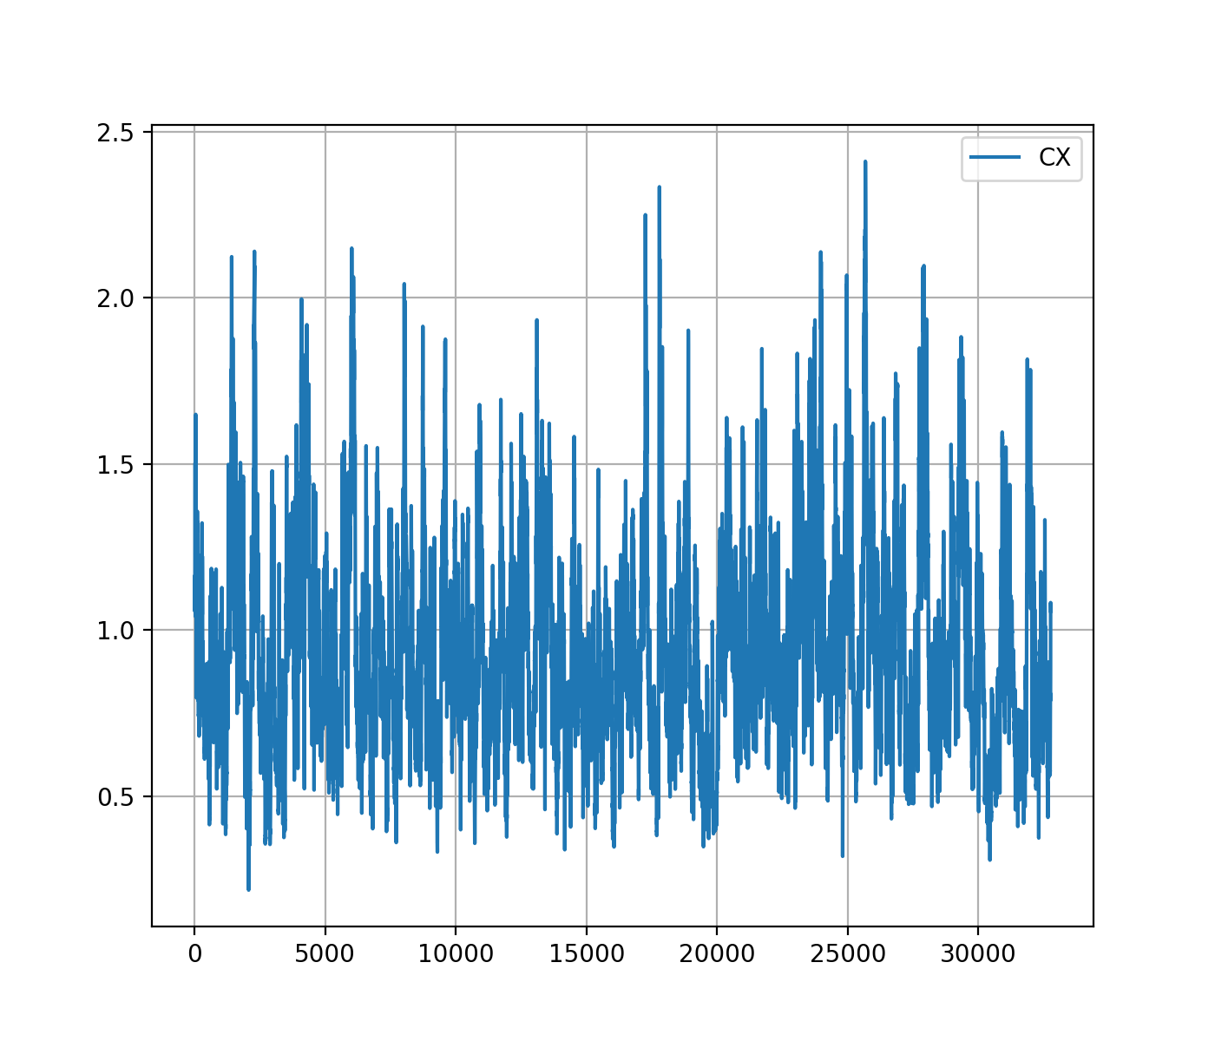

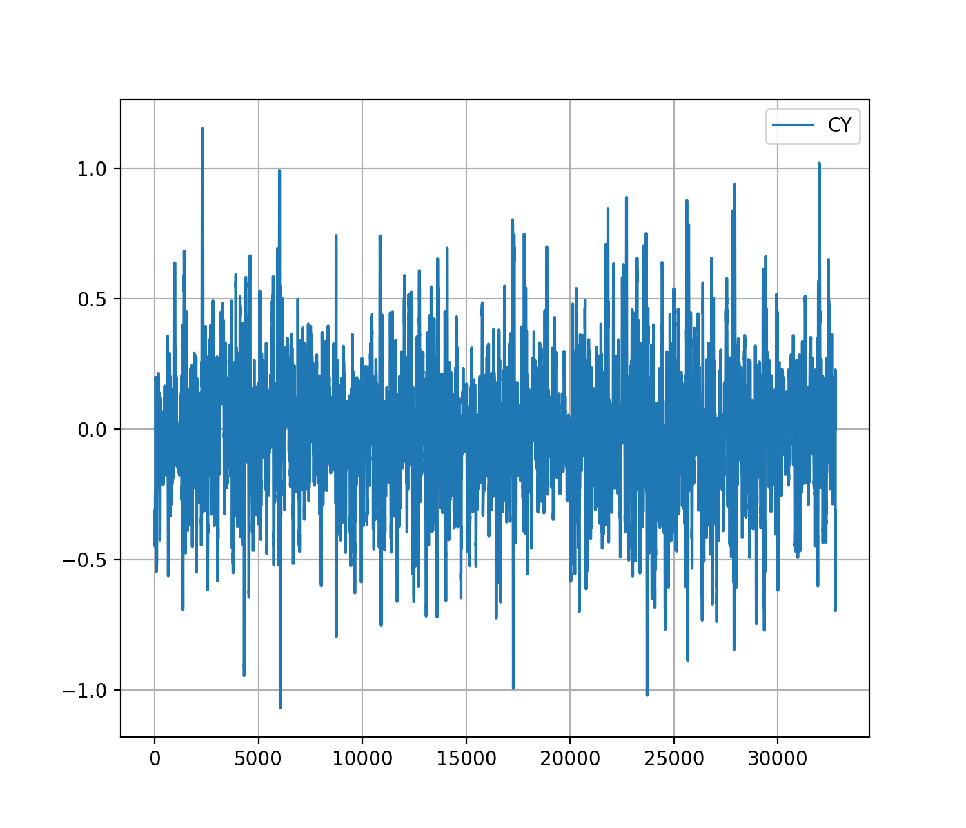  
Таблица 2. ТПУ 111_4, RUMB=0 Аэродинамические коэффициенты сил и моментов

|  |  |  |  |  |  |  |  |  |
| --- | --- | --- | --- | --- | --- | --- | --- | --- |
| СИЛА | СРЕДНЕЕ | RMS | СТАНДАРТНОЕ ОТКЛОНЕНИЕ | МАКСИМУМ | МИНИМУМ | РАСЧЕТНОЕ | ОБЕСП+ | ОБЕСП- |
| CX | 0.94 | 0.99 | 0.31 | 2.41 | 0.22 | None | None | None |
| CY | -0.02 | 0.24 | 0.24 | 1.15 | -1.07 | None | None | None |

5. Числа Струхаля суммарных сил

|  |  |  |  |
| --- | --- | --- | --- |
| fi | st(cx) | st(cy) | st(cmz) |

6. Числа Струхаля давлений датчиков

|  |  |  |  |  |  |  |  |  |  |  |  |  |  |
| --- | --- | --- | --- | --- | --- | --- | --- | --- | --- | --- | --- | --- | --- |
| ДАТЧИК | x | y | z | 0 | 5 | 10 | 15 | 20 | 25 | 30 | 35 | 40 | 45 |